Building Cladograms
And
A Comparative DNA Analysis

Document Overview:

This is a series of activities of help students understand the nature of evolutionary relationships in terms of morphological and genetic similarities and differences. The students will first be introduced on what is, and how to, build a cladogram. This practice activity will then prepare them for the more complex DNA analysis of a large group of mammals. In the end, the students will attempt to build a cladogram on the relationships of the mammals.

In the secondary and more complex mammal analysis, the students will replicate the logical processes that Darwin employed during his scientific career. They will then continue to focus their analysis by utilizing the techniques of the Human Genome Project from the late 20th century by sequencing a specifically shared mammalian gene common to all the organisms in the lab.

Lastly, the students will be directed to the Biological Super Computer Center at San Diego State University to have the computer build the cladogram, based on the gene sequences of the various organisms.

Ironically, the students will find that their first attempts at building evolutionary relationships from their intuitive (Darwinian) perspective and pretty close to the more sophisticated Super Computer generated analysis.

Minnesota State Academic Science Standards:

9.4.3.3.1 Describe how evidence led Darwin to develop the theory of natural selection and common descent to explain evolution.

9.4.3.3.2 Use scientific evidence, including the fossil record, homologous structures, and genetic and/or biochemical similarities, to show evolutionary relationships among species.

Key Terms:

Cladogram, Evolution, Gene Sequences, Mutations, Relationships, Super Computer

Type of Activity:

This is a hands-on “dry” lab that will have the students analyzing a set of data and attempting to make an evolutionary relationship among the organisms by building a series of cladograms. They will learn and practice making a cladogram first, and then utilize this new found skill later in the lab.

Duration:

This is a lengthy activity set that might need as many as 3 to 4 days to complete based on a 45-55 minute class period.

Connection to Nobel speakers:

Svante Pääbo, director of the Max Planck Institute for Evolutionary Anthropology, Leipzig, Germany.

Teacher Tips:

Cladograms are essential for students to understand evolutionary relationships of organisms and in this series of activities; students will be practicing and building a group of cladograms. The first set will be an introduction to a cladogram and your students will practice building one based on the logic of anatomy and structural similarities. You, and your students, will be directed to two different websites to learn the science of cladogram construction.

In the second half of the activity, the students will take their new found skill and build evolutionary relationships of various mammals using three different techniques. One historically based, using the same logic that Darwin used on his trip with the HMS Beagle. They will continue to focus the cladogram by using the science of the Human Genome Project, and the third way using a modern research tool supercomputer at San Diego State University.

This is a very “dry” lab type of activity that is based strongly in the logic of anatomy and gene sequences. An understanding of mutations would be helpful but not necessary to complete the lab correctly.

*If possible, print the animal cards in color and have them laminated for continued use in subsequent semesters. The upfront cost might be prohibitive at first but will pay off in the end as the clarity of the pictures is important for success with the lab.

Materials:

While these will be repeated later in the formal lab write up I will still state some of them here:

- Groups of students (preferably 2 – 3 max)
- A dependable internet connection
- Some type of computer (iPad, Chromebook, Mac, PC etc…)
- Laminated sets of animal pictures provided with the lab
- Printed worksheets from the Building Cladograms website for practice organizing data
- Tape
- Scissors
- Highlighters
- Rulers

Activity:
1. Visit two different websites to learn what is, and how to build a cladogram:

a. Visit the Northwestern University evolution website and watch a cool little cartoon video on what a cladogram is and how do you build one. This is a very fun site and one worth starting out with to introduce your students to the concept. Watching it a couple of times is easy since it’s only a few minutes in length.

http://ccl.northwestern.edu/simevolution/obonu/cladograms/Open-This-File.swf

b. The second website is from Boston University:
http://www.bu.edu/gk12/eric/cladogram.pdf and is adapted from the ENSI/SENSI lesson plan: Making Cladograms http://www.indiana.edu/~ensiweb/home.html

c. Print out copies of this activity and have your students play with how to make a cladogram from the list of organisms provided with the activity. This is not as easy as it might appear due to the nature of the organisms involved, be prepared to find some frustrated students as they work out the logic of cladogram construction.

2. Once the students have the concept down, continue with the remainder of the “lab” in the proceeding instructions.

Comparative DNA Analysis
Cladogram Development ~ Part 2

In the past, organisms were categorized according to visible similarities that they shared anatomically. For example, horses and zebras share many characteristics which led scientists to believe that they were closely related. Today scientists can do this analysis at the molecular level, something that Darwin would never have imagined. Geneticists and evolutionary biologists isolate sections of DNA and make a cross comparison analysis in order to confirm how closely related various organisms are genetically. This science has been given the new name of “Bioinformatics” and while the process has been difficult and time consuming in the past, the use of computers to “crunch the data” has made life and data analysis easier than ever before. This activity is designed to help you understand how difficult comparative DNA analysis can be and then show you how to use an online DNA analysis engine to determine how a group of organisms is related as it makes the cladogram for you. Pretty cool huh?
Materials:
Lab Packet SDSC Biology Workbench website
2 Scissors Tape
Bioquest website 2 Highlighters Ruler

Procedure:
1. Cut out the supplied pictures from the back of this lab and then do your best to quickly categorize them into a number of groups. Use an organizational style that is based on anatomy and shared physical characteristics.
- Create a list of your groups and list them in the space below:

- Was this an easy or difficult task, based on the limited information you had to work with?

- If you had more information about each organism, could this have been a more scientifically accurate analysis?

- Hypothesize and evolutionarily order your groups from the oldest to the youngest. Speculate which groups evolved earlier than the others:

- Explain your scientifically based rationale for the evolutionary order of your organisms:

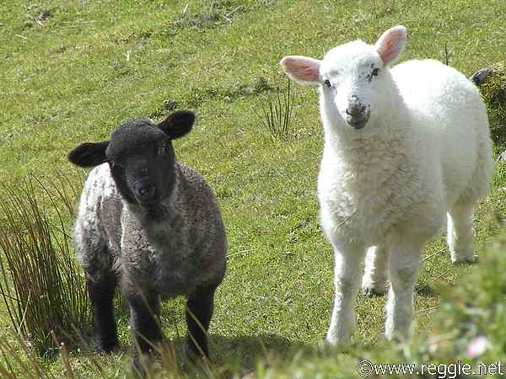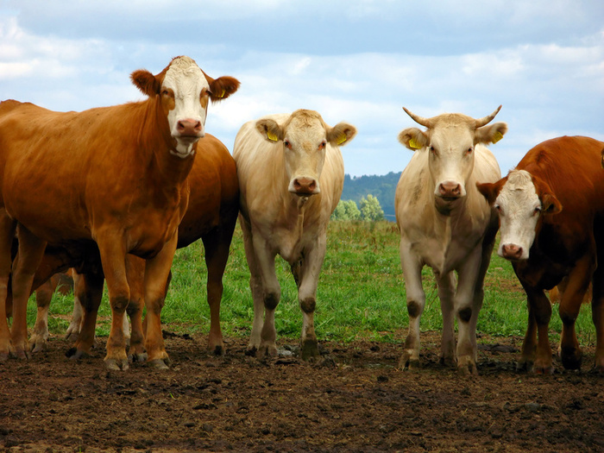
Sheep Beef Cattle
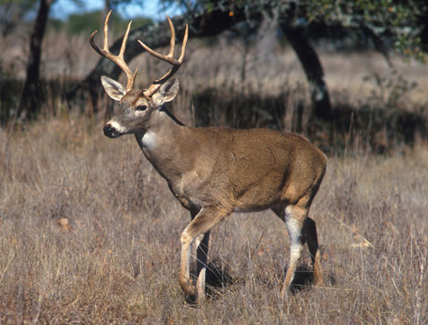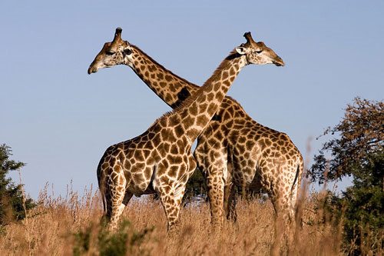
White Tailed Deer Giraffe
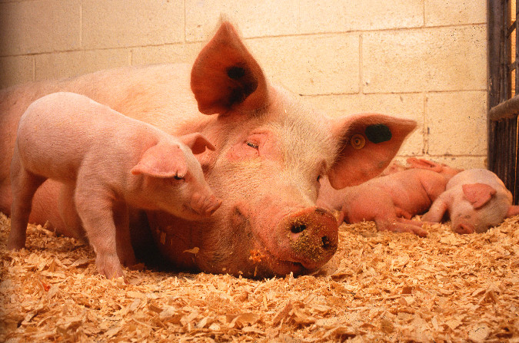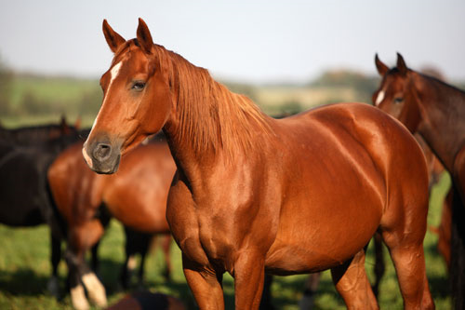
Domesticated Pig Thoroughbred Race Horse

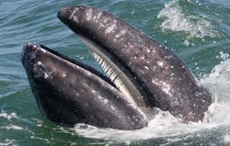
Baleen Whale (those are NOT teeth) Peccary
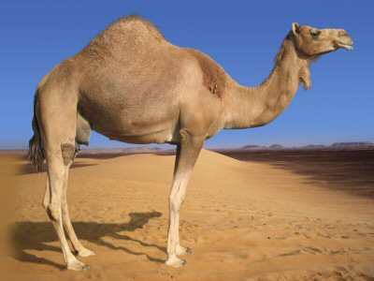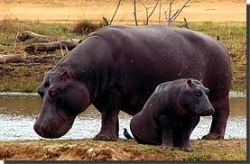
Camel Hippopotamus
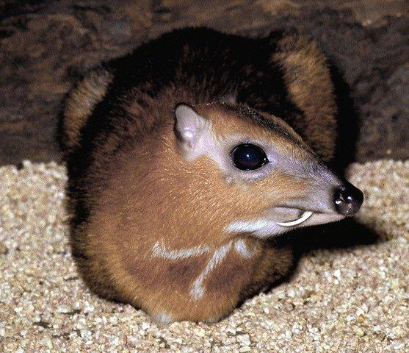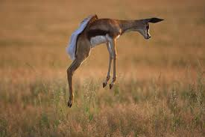
Chevrotain Springbok….get it?
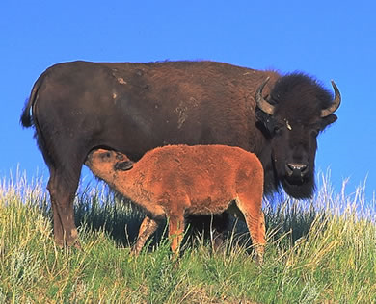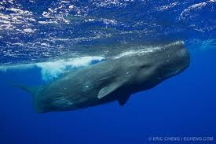
American Bison Sperm Whale
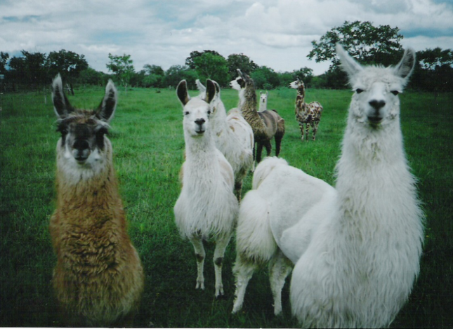
Llamas Bottle nosed dolphin
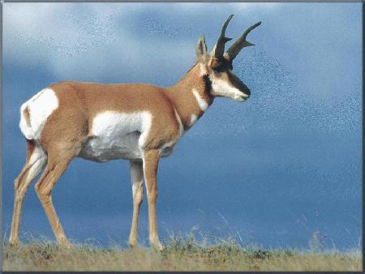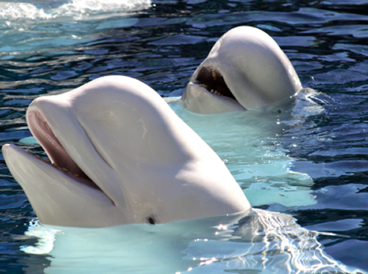
Pronghorn (antelope) Beluga Whale
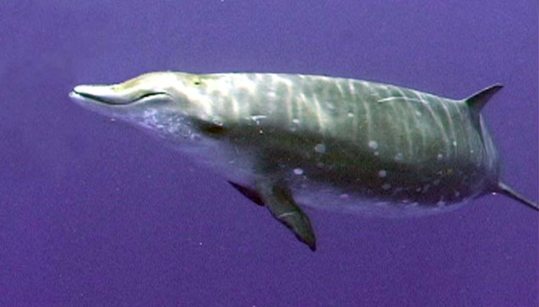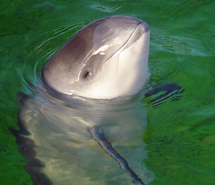
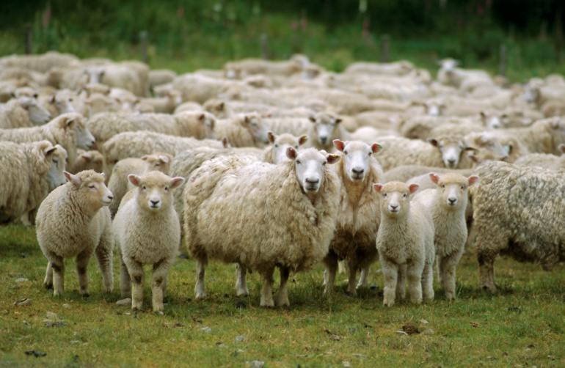
Beaked whale Porpoise
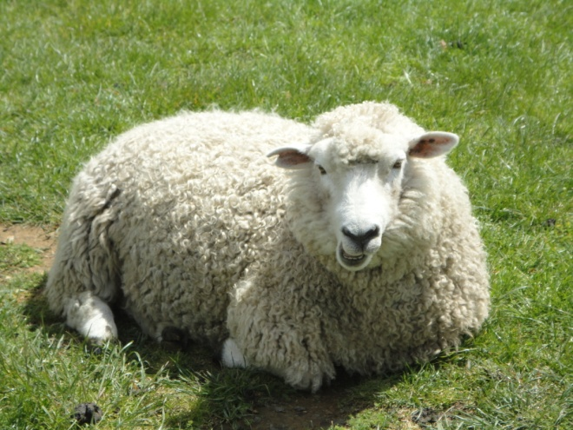
Sheep Beepsh!

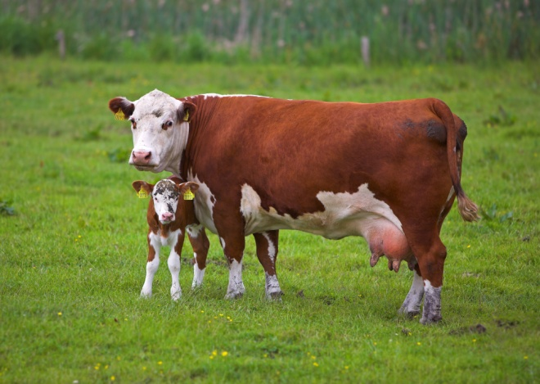
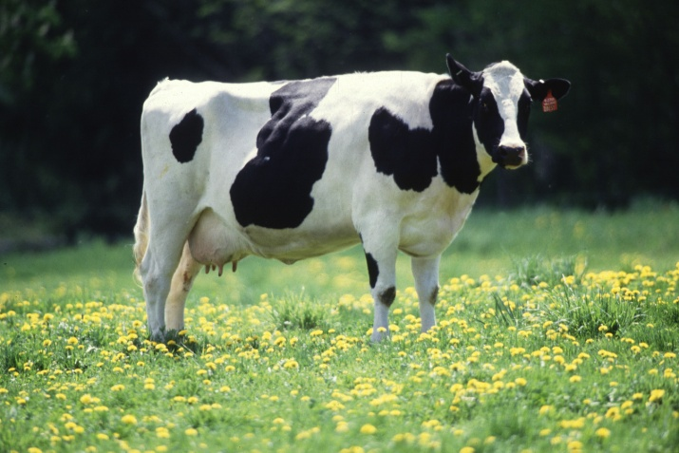

Daisy (Holstein Milk Cow) Bessie (Hereford Beef Cow)

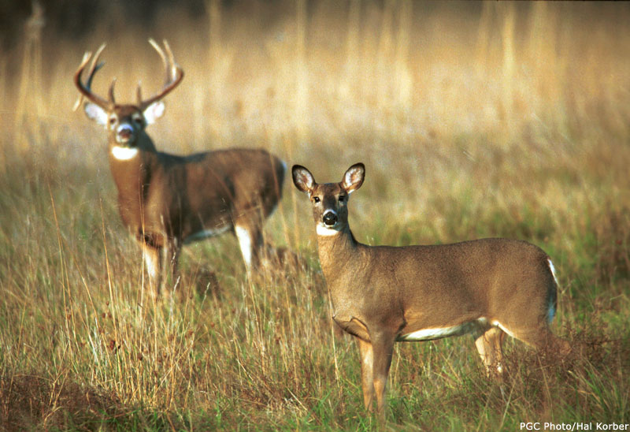
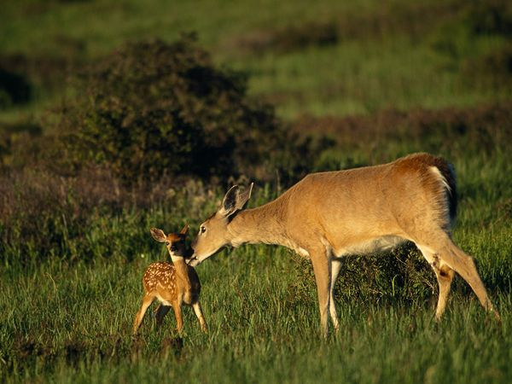

White Tailed Deer Buck and Doe (nice rack…it’s a sexual selection thing)

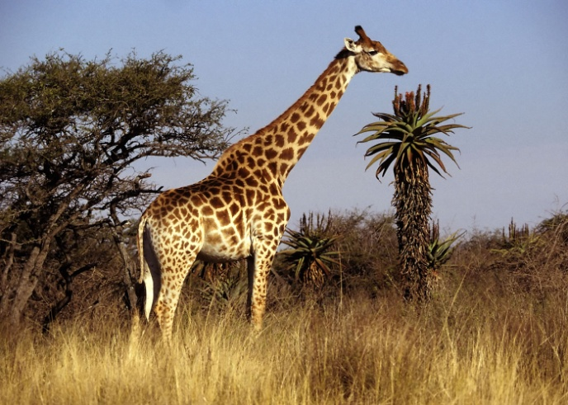
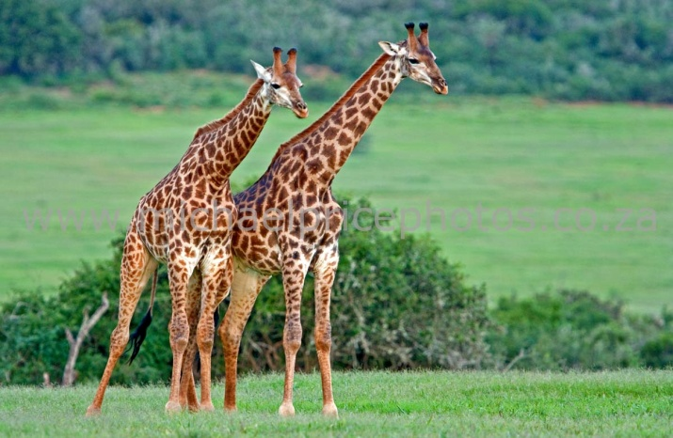

Melman (looking for his meds) Melman (not with Gloria!)
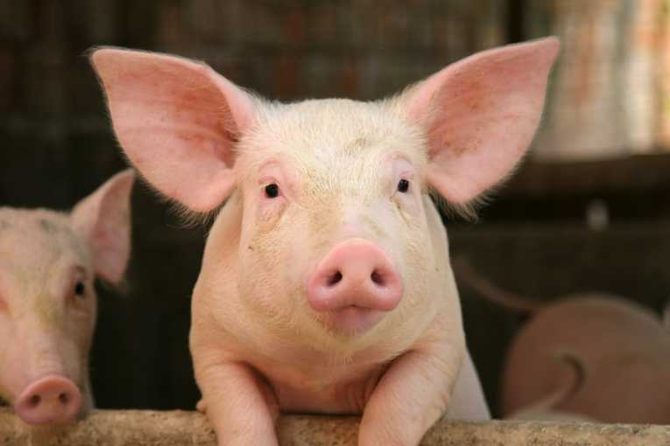
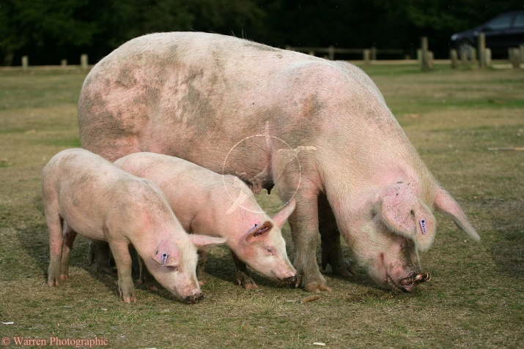

Three little piggies Pig (sort of adorable)

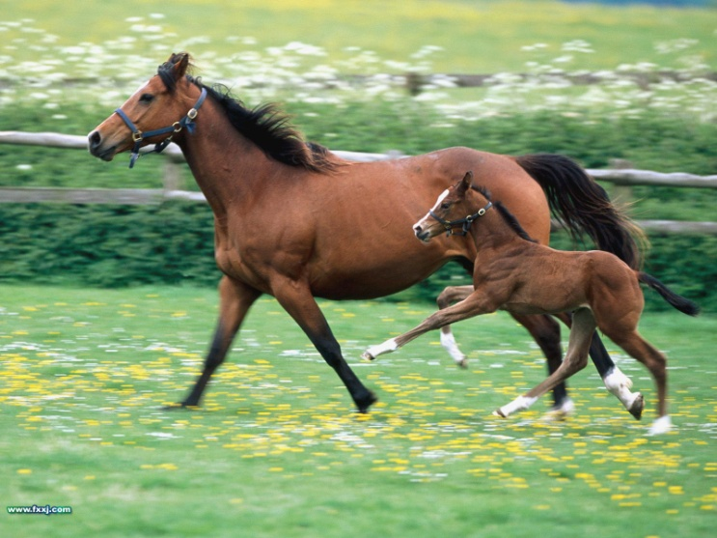
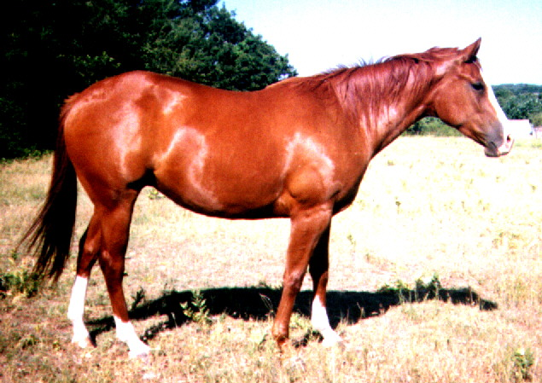

American Quarter Horse Thoroughbred Mare and Foal
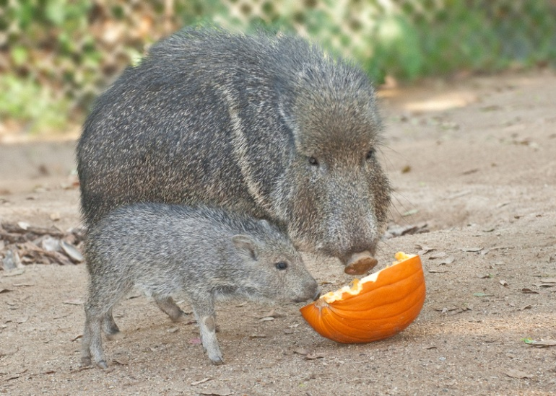
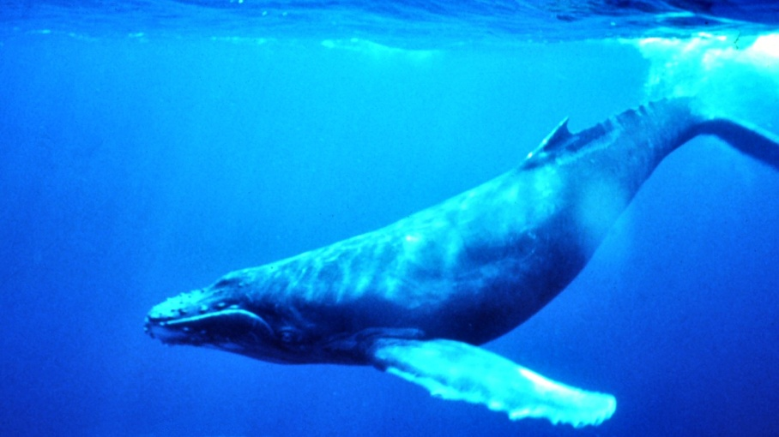

Beaked Whale Peccary and young

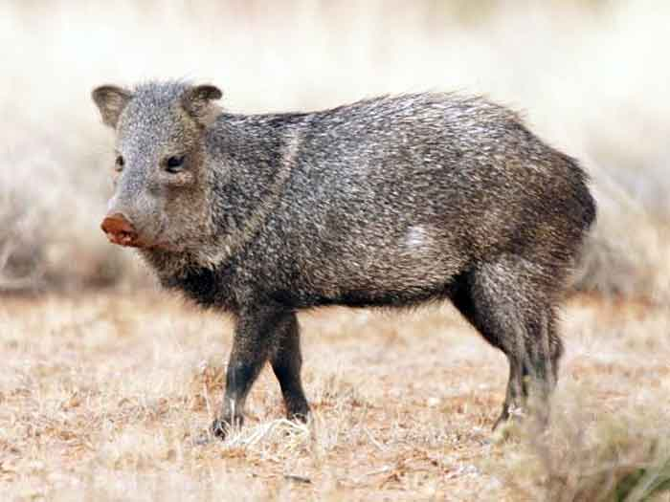
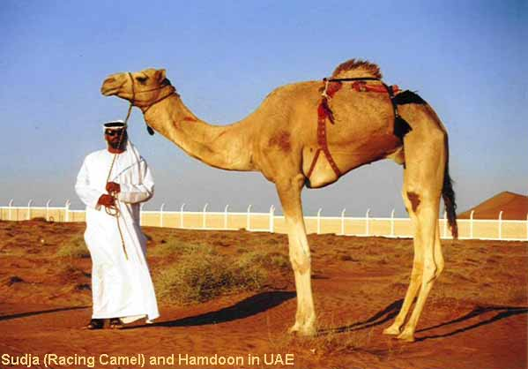

Peccary Racing Camel

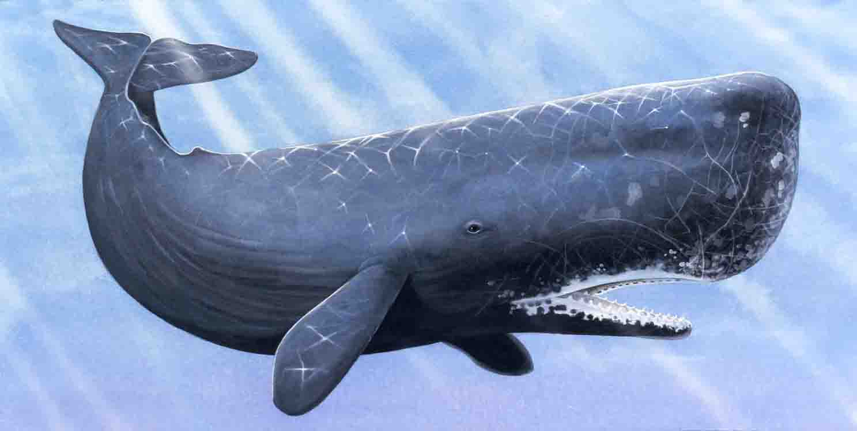


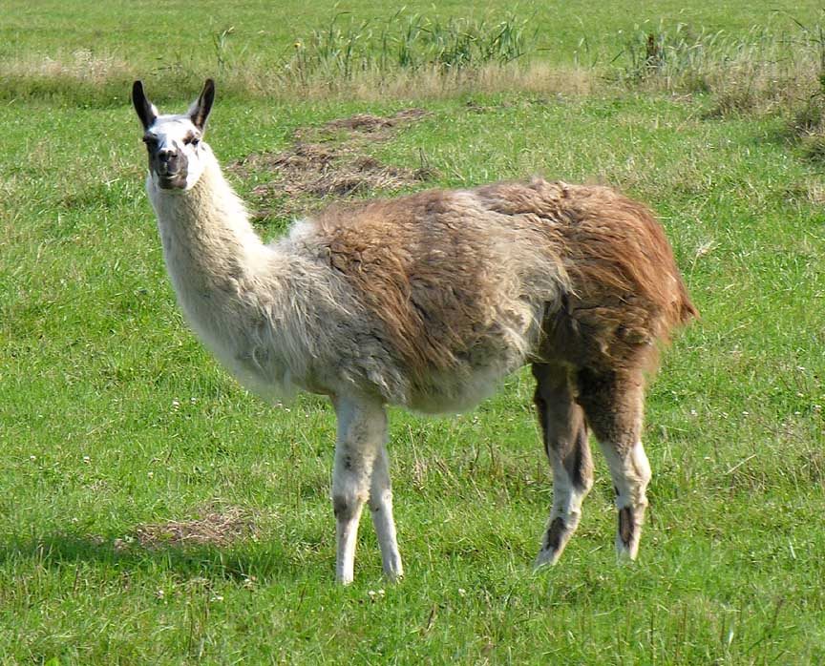
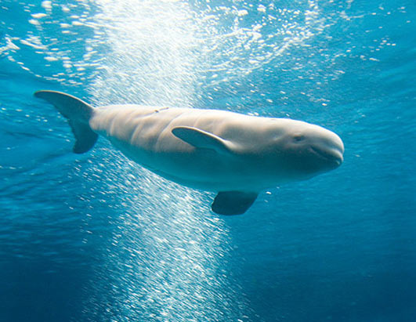
Dolphin Sperm Whale

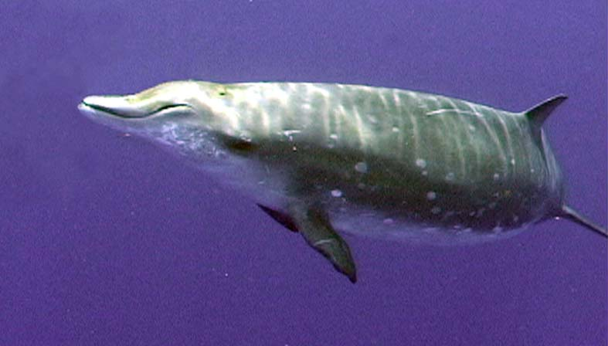
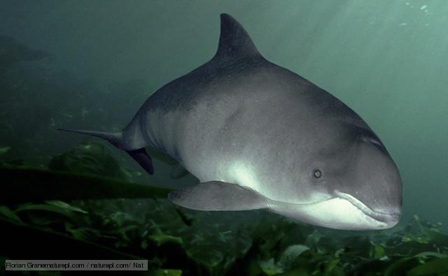
Beluga Whale Llama

Porpoise Beaked Whale

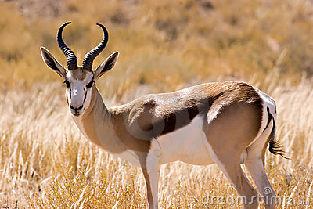
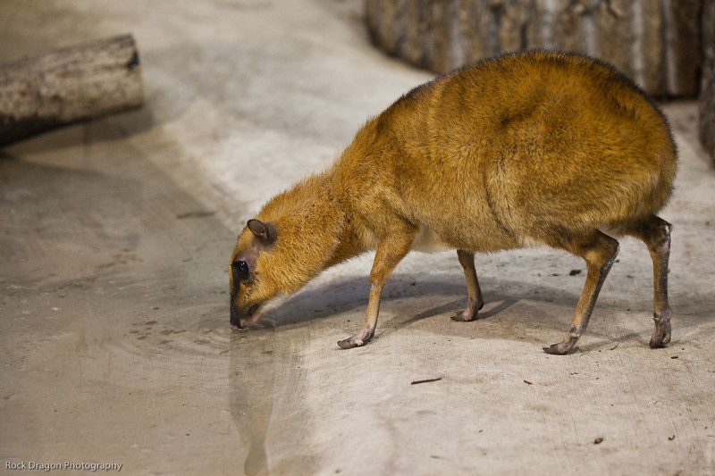

Chevrotain Springbok

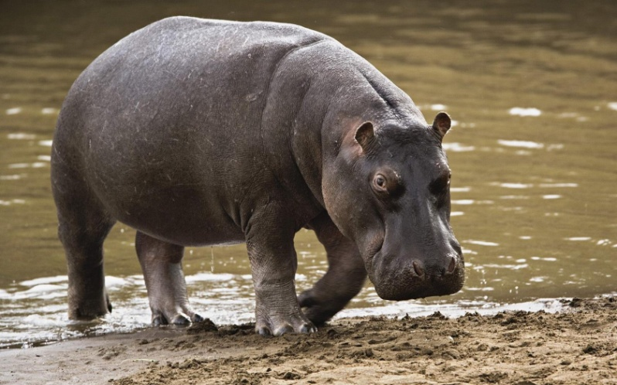
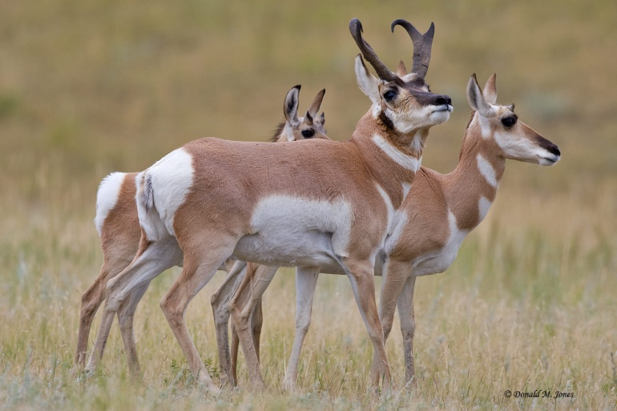

Pronghorn Hippo
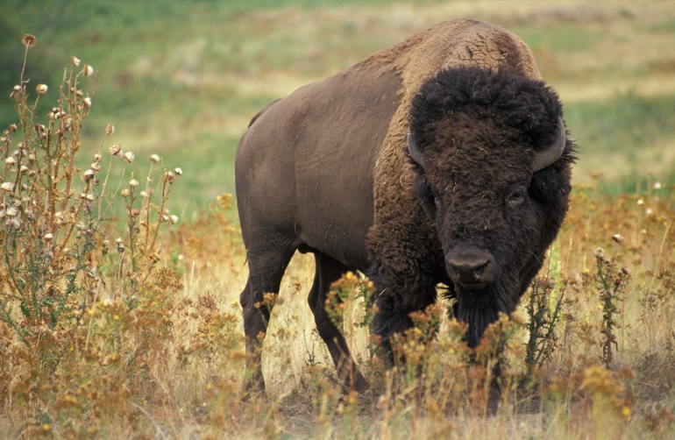

Bison

Family Names:
Bovidae: cattle family
Cervidae: deer family
Tragulidae: chevrotain family
Delphinoidea: dolphin and porpoise family
Physeteridae: sperm whale family
Ziphiidae: beaked whale family
Mysticeti: baleen whale family
Hippopotamidae: hippo family
Suidae: pig family
Tayassuidae: peccary family
Camelidae: camels and llamas
Equidae: horse family

2. Take a look at the following sections of DNA for the organisms that we will work with in this lab. These sequences have been obtained from the BioQuest Website which is an undergraduate research engine from Beloit College in Beloit, Wisconsin. These are the partial yet actual sequences of DNA from the genome of these animals. They are coding for a gene called b -casein exon 7 which is a gene that allows us to process and absorb calcium for the proper formation of bones and teeth. This gene is found in many lines of vertebrate organisms.
b -casein exon 7 gene

Bovidae:

ATCCACCCCTTTGCCCAGGCACAGTCTCTAGTCTATCCCTTCACTGGGCCCATCCCTAAC

Cervidae:

ATCCACCCCTTTGCCCAGACACAGTCTCTAGTCTATCCCTTTGCTGGGCXCATCCCTTAC

Giraffidae:

ATCCACCCCTTTGTGCAGACACAGTCTCTAGTCTACCCCTTCGCCGGACCCATCCCTCAC

Tragulidae:

ATCCACCTCTTTCCCCAGCCACAATCTCTAGTCTTCCCCCCCACTGGGTCCTTCCCCTAC

Delphinoid:

ATCCACCAATTTTCCCAGCCACAGCCTCTAGTCTATTCCTACACTGGGCCAATCCCTTACCCTATTCTTACACAAAACATCCTGCCTCTTGCTCAGCCCCCTGTGGTGGTGC

Physeterid:

ATCCACCGCTTTTCCCAGCCACAGCCTCTAGTCTATTCCTACACTGGGCCAATCCCTTACCCTATCCTTCCACAAAACATCCTGCCTCTTGCTCAGCCCCCTGTGCTGGTGC

Ziphiidae:

ATCCACCACTTTTCCCAGCCACAGCCTCTAGTCTATTCCTACACTGGGCCAATCCCTTACCCTATCCTTCCTCAAAACATCCTGTCTCTTGCTCAGCCCCCTGTGGTGGTGC

Mysticeti:

ATCCACCACTTTTCCCAGCCACAGCCTCTAGTCTATTCCTACXCTGGGCCAATCCCTTCCCCTATCCTTCCACAAAACATCCTGACTCTTGCTCAGCCCCCTGTGGTGGTGC

Hippopota:

??????CCCTTTTCCCAGCCACAGCCCCTAGTCTATCCCTACAATGGTCCCATCCCTTACCCTATCCTTCCACAAAACATCCTGCCTCTTGCTCAGCCCCCTGTGGTGGTGC

Suidae:

ATCCACCAGTTTCCCCAGCCTCAGCCTCTAGCCCATCCTTACACCGAGCCCATCCCTTACCCCATCCTTCCACAAAACATCCTGCCTCTTGCCCAGGTCCCTGTGGTGGTGC

Use this larger pig sequence later in the lab (question #7a)

[CTCTTCTTCATCCTGAAGTAATGAAAGATTCCAAAGCTAAGGAGACCATTGTTCCCAAGCGTAAAGGAATGCCCTTCCCTAAATCTCCAGCAGAGCCTTTTGTGGAAGGCCAGAGCCTAACTCTCACCGATTTTGAAGTCC]

Camelidae:

ATCTACACCTTTCCCCAGCCCCAGTCTCTAGTCTATTCTCACACTGAGCCCATCCCTTACCCTATCCTTCCACAAAACTTTCTGCCGCCTCTTCAGCCTGCTGTGATGGTAC

Equidae (Outgroup):

ATCTTTCACTTTGTCCAGCCACAGCCTGTAGTCTATCCTTATACTGAGCCACTCTCTTACGCTGTCCTTCCACAAAACATCCTGCCTGTTGCTCAGCCTCCTGTAGCGCTGC

Tayassuid

????????????????????????????????????????????????????????????????????????????????????????????????????????????????????????????????????GTGATGGAAGACCCCAAACCTAAGGAGACCGTTGTTCACAAGCGTAAAGGAATGTCCTCCCCTAAATCTCTAGGAGAGCCTTTTGTTGAAGGCCAGAGCCTAACTCTCACTGATTTCGAAAGTC

3. You are now going to replicate a style of data analysis that was common even as recently as the late 1990’s with the Human Genome Project. After we take a whack at the analysis, we will use a more convenient and modern method of this same analysis by using a computer program to do the heavy lifting for us.
a. Start off by carefully cutting out each strip of DNA from the groups above. Keep them organized, getting confused is pretty easy to do.
b. Set aside the last group, Tayassuid, and save it for later in the lab. Do the same with the bold larger pig sequence.
4. Based on your visual analysis from earlier in your lab, take three groups that you are fairly certain must be closely related. Line their DNA sequences very closely together on a blank piece of paper and give them a bit of tape to hold them in place. (Hint: the closer you tape them together the easier the next task will be) Create three or four groups of these three closely related DNA sequences.
5. Using a highlighter, go through the sequences letter by letter and carefully highlight those sections where it appears that a mutation has occurred in one or more of the strips. A ruler will be most helpful and prevent you from going batty and cross-eyed at the same time.
Example:
ccagtttacggactacgctctcaggcattctctagagaccagcatgacacgattagacatatacagtacagattcagccctg
ccagtttacggactacgctctcacgcattctctagacaccagcatgacacgaatagacatatacagtacagattcagcccag
ccagtttacggactacgctctcacgcattctctagagaccagcatgacacgactagacatatacagtagagattcagccccg
- Are there any groups that you organized which are closely related? If so, which groups?

- Was this conclusion supported or refuted by the DNA sequence/mutation comparison technique?

- Are there any groups that surprisingly don’t appear closely related by the DNA sequences? If so, which groups?

6. Now take a look at the hippo’s DNA sequence. When scientists collected this sequence, the first 6 letters were mistakenly left off. With great frustration you may be able to figure out the missing sequence, but a computer would be able to stitch together the missing bases much more efficiently and quickly. You will notice that the same process has occurred with the peccary sequence. Furthermore, it won’t line up well with any of the other DNA until you dig deeper into the genome of the target organism.
7. By observing the photo’s from earlier in the lab, what group of organisms would you expect the peccaries to be most closely related to?
a. Now take the peccary sequence and carefully line it up with the larger pig sequence. Tape the two strips so that they match up (hint: the peccary line should line up better about ¼ of the way into the pig’s 2nd line)
b. highlight any mutations you can detect.

8. How difficult has this whole experience been? This was the way that many sequences in the early days of genome work were checked compared and verified in the lab. Fortunately, some rather smart chaps have developed a series of computer programs to automate the whole process and sequence genes efficiently with less stress and tedium.

---------------------------------------------------------------------------------------------------------------------
Pull up the following two websites:
BioQuest Curriculum Consortium:
http://bioquest.org/bedrock/problem_spaces/whippo/data2.php
San Diego Supercomputer Center: Biology Workbench
http://workbench.sdsc.edu/

9. Start by going to the BioQuest website. You will be taken to a page that has the sequences of a variety of genes from the organisms in the lab. You will be testing the sequences of the b casein exon 7 gene. Find this gene and click on the raw link. *Do not change anything about this data set; it is in a format that will be needed at the subsequent supercomputer web engine. Save a text file version of this data on your desktop with a file name that you can remember for later in this activity.
10. Leave this page and go to the other link at the SDSC website. (At this point it’s going to get technical, stay with me here…)
11. Since you’re a first time user, create an account and then log in by clicking on the “Click to Enter the Biology Workbench 3.2”
12. Scroll down and find the gray “Session Tools” box and click on it.
Note: if at this point you do not see the correct screen options that I’m referring to, you will need to go to the top your current page, find the Biology Workbench Title and click once or twice on the “click here to toggle between menus and buttons” to get the proper format on the pages. It’s a bit of a hassle but ask if you have questions.
13. Go to the pull down menu that says “Select Session: Then Choose Tool” and change it to “Start New Session”.
Note: You will always hit the “run” button to make something happen at this website.
14. Give a name to your session in the Session Description box; something that makes sense to you and your team. Then hit the “Start New Session” button.
15. Now go to the gray “Nucleic Tools” and click on it.
Note: if at this point you do not see the correct screen options that I’m referring to, you will need to go to the top your current page, find the Biology Workbench Title and click once or twice on the “click here to toggle between menus and buttons” to get the proper format on the pages. It’s a bit of a hassle but ask if you have questions.
16. Go to the pull down menu that says “Select Session: Then Choose Tool” and change it to “Add New Nucleic Sequence”.
17. Now upload your DNA sequences from the text file you saved earlier in the lab on your desktop by clicking on “Browse”, selecting the file you want and then “Upload File” into this web engine.
18. Now find the gray “Save” box and click on it.
19. Go to the pull down menu at the bottom of the page that says “Select Sequence(s): Then Choose Tool” and select “Select All Sequences”. You should notice that all the radio buttons on the left side of the page will get a check mark.
20. Go back to the pull down menu at the bottom of the page that says “Select Sequence(s): Then Choose Tool” and select “CLUSTALW – Multiple Sequence Alignment” and click on it.
21. At the lower left hand corner of the screen, go to the pull down menu that says “Unrooted Tree” and change it to “Rooted and Unrooted Trees” . Finally, click on the gray “Submit” button and relax, you’re almost there; this could take a few minutes.

*At this point the supercomputer in San Diego has done the analysis of the DNA sequences of all your organisms in the data set, have cross compared them and drawn two types of cladograms (phylogenetic trees) for your use. The blue sections of DNA code are aligned sequences. The black sections have mutations in them.

Questions:
Use this data (cladograms: rooted or unrooted) to answer the next series of questions. The unrooted phylogenetic tree is actually more accurate to observe about the evolutionary relationships of your organisms. Not only can you see how the animals are grouped, but the distances of the lines represent the amount of differences that exist in their DNA sequences. Long lines equate to large differences and short lines equate to closely related small differences.
1. Based on this DNA data, what group is most closely related to the whales?

2. What is your reaction to this finding?

3. By looking at your unrooted tree, what group of organisms are the most closely linked to each other evolutionarily speaking?

4. Check out the connection of hippos to whales and hippos to pigs. What group of organisms is most closely related to the hippos?

5. Look at the entire tree and determine which group of organisms is the least connected to the group as a whole. Which group is this?

6. Discuss among you teammates whether or not the common ancestor to all of these organisms lived on water or land. Give an explanation

